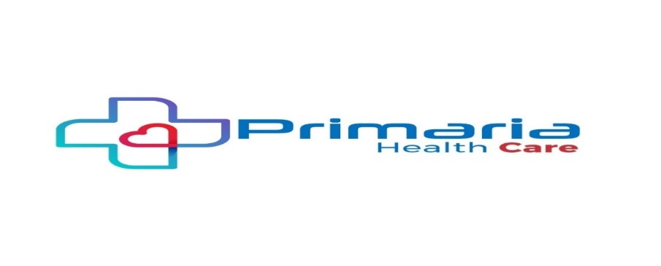
PURCHASE ORDER
Date: -07-2025
Invoice No : 28
PO No :
GST NO :- 37ABEFP6758K1ZK
FROM BILL TO
COMPANY: PRIMARIA HEALTHCARE LLP. Hospital Name: : Malathi Dental Clinic
ADDRESS:.
EMAIL ID: afrozs@primariahealthcare.com EMAIL ID:
PHONE NO: +91 8121-222-570 PHONE NO:

S.No | NAME OF THE PRODUCT | QTY | Price Each | Price | GST % | Total Amount
1. | 1000 mouth masks-1000 mouth masks-Face Mask - 3 Layers ShalexFace Mask - 3 Layers Shalex | 10 Box | 126/- | 1,260/- | 5% | 1,323/-

TERMS & CONDITIONS WILL APPLY
- Payment: 100% advance payment before delivery.
- Delivery Period: Delivery can be as per the schedule required by client. Within 4-6 weeks
- Logistics: Cost for Logistics including inclusive.
- PRIMARIA HEALTHCARE Bank details:
- Account Name: PRIMARIA HEALTHCARE
- Current Account No: 664905500780.
- IFSC CODE: ICICI0004919
- Branch Address: Primaria Healthcare, Kothapet, Guntur- 522001, A.P, India.
- Validity: The prices are valid for 30 days from the date of quotation. After that kindly contact us for confirmation. Kindly feel free to contact us for any clarification or further details. We trust the above is in line with the requirement and we look forward to receiving your value purchase order at an early date.

Signature of Authority

